### Fitness APP API

### A INTERNSHIP REPORT

***Submitted by***

**Dhandhukia Dev Hiteshbhai**

**190320107014**

***In partial fulfilment for the award of the degree of***

## BACHELOR OF ENGINEERING

### In Computer Engineering

**L.J. Institute of Engineering and Technology**



**Gujarat Technological University, Ahmedabad**

**[April,2023]**

 

### L.J. Institute of Engineering and Technology

LJ Campus, Near Sarkhej-Sanand Circle, Makarba, Ahmedabad, Gujarat 382210

**CERTIFICATE**

This is to certify that the project report submitted along with the project entitled **Internship** has been carried out by **Dhandhukia Dev Hiteshbhai** under my guidance in partial fulfilment for the degree of Bachelor of Engineering in **C.E**, 8th Semester of Gujarat Technological University, Ahmedabad during the academic year 2022-23

Prof. Dipikia Bavaliya Prof. Shruti Raval

Internal Guide Head of department



**L.J. Institute of Engineering and Technology**

LJ Campus, Near Sarkhej-Sanand Circle, Makarba, Ahmedabad, Gujarat 382210

**DECLARATION**

We hereby declare that the **Internship** report submitted along with the Internship entitled submitted in **Fitness APP API** partial fulfilment for the degree of Bachelor of Engineering in to Gujarat Technological University, Ahmedabad, is a bonafide record of original project work carried out by me at **Solute Technolabs LLP** under the supervision of **Bhoomi Vasani** and that no part of this report has been directly copied from any students' reports or taken from any other source, without providing due reference.

**Name of the Student Sign of the Student**

**1 DHANDHUKIA DEV HITESHBHAI**

**ACKNOWLEDGEMENT**

This Internship work has been the most practical and exciting part of my learning experience, which would be an asset for me and also for my future carrier.

With a deep sense of gratitude and respect, I wish to express my heartfelt appreciation to all those who have contributed to this project, both explicitly and implicitly, without the co-operation of whom, it would not have been possible to complete this.

No system is created entirely by individual. Many people have helped to create this system and each of their contribution has been valuable. Proper organization of concept and analysis of system is due to keen interest and helping hand of our teachers and colleagues.

I would like to thank my Head of Department **Mrs. SHRUTI RAVAL**, who was a constant source of inspiration.

My most sincere thanks to my internship guide **Prof.Dipikia Bavaliya**, for her kind co-operation and who has always been guiding, encouragingand motivating us throughout the project. I am grateful to my college **L.J. Institute of Engineering and Technology** for providing me all the required resources and a good working environment.

I would like to thank my external guide, **Mr.Bhoomi Vasani**, for supporting me throughout the internship work and motivating me for my abilities and carrier. I also would like to thank the organization “**Solute Technolabs LLP**” who supported me of my internship.

# ABSTRACT

The project titled “Fitness APP API” gives the complete details of the technology and the project developed by me in in internship period with the company Solute Technolabs in 3 month of internship period. The main objective of this project was to get the hands on the industrial technologies and brush up the concepts learned by me in 3.5 years of my college and implement it into real world project.

Throughout my internship, I acquired knowledge and skills in Node.js as a programming language. I began by building a strong foundation in JavaScript and then progressed to TypeScript. Additionally, I gained proficiency in popular Node.js frameworks, such as Express.js and Nest.js.

Also, some screen shots and the codes for testing is provided below for the better understanding of the project.

# List of Figures

Fig 2.1 Chapter 2/Stages of Production 5

Fig 4.1 Chapter 4/Structure Design. 7

Fig 4.2 Chapter 4/System Feasibility 9

Fig 5.1 Chapter 5/System Design 10

Fig 5.2 Chapter 5/Database Design 10

Fig 6.1 Chapter 6/VS Code 11

Fig 6.2 Chapter 6/Program Code-1 12

Fig 6.3 Chapter 6/ Program Code-2 12

Fig 6.4 Chapter 6/ Program Code-3 13

Fig 6.5 Chapter 6/ Program Code-4 13

Fig 6.6 Chapter 6/ Program Code-5 14

Fig 6.7 Chapter 6/ Program Code-6 14

Fig 6.8 Chapter 6/Program Code-7 15

Fig 6.9 Chapter 6/ Program Code-8 15

Fig 6.10 Chapter 6/ Program Code-9 16

Fig 6.11 Chapter 6/ Program Code-10 16

Fig 6.12 Chapter 6/ Program Code-11 17

Fig 6.13 Chapter 6/ Program Code-12 17

Fig 6.14 Chapter 6/ Program Code-13 18

Fig 6.15 Chapter 6/ Program Code-14 18

Fig 6.16 Chapter 6/ Program Code-15 19

Fig 6.17 Chapter 6/ Program Code-16 20

Fig 6.18 Chapter 6/ Program Code-17 20

Fig 6.19 Chapter 6/ Program Code-18 20

Fig 6.20 Chapter 6/ Program Code-19 20

Fig 6.21 Chapter 6/ Program Code-20 20

Fig 6.22 Chapter 6/ Program Code-21 20

Fig 6.23 Chapter 6/ Program Code-22 20

Fig 6.24 Chapter 6/ Program Code-23 20

Fig 6.24 Chapter 6/ Program Code-24 20

Fig 6.24 Chapter 6/ Program Code-25 20

Fig 6.24 Chapter 6/ Program Code-26 20

Fig 7.1 Chapter 7/Result 20

# List of Tables

Table 3.1 Chapter 3/Planning. 4

# List of Abbrevations

1. npm - Node Package Manager
2. CLI - Command Line Interface
3. API - Application Programming Interface
4. HTTP - Hypertext Transfer Protocol
5. CRUD-Create ,Read ,Update ,Delete
6. SQL-Structured Query Language

# Table of Contents

Acknowledgment V

Abstract VI

List of Figures VII

List of Tables VIII

List of Abbreviations IX

Table of Contents X

Chapter 1 Overview of the Company 1

* 1. History of Company 1
  2. Scope of Work 1

Chapter 2 Overview of different departments of the organization and Layout of the production being carried out in the company 2

2.1 Stages of production 2

Chapter 3 Internship and Project 4

* 1. Internship Summary 4
  2. Purpose 4
  3. Objective 4
  4. Scope 5
  5. Project Planning and Scheduling 5

Chapter 4 System Analysis 6

* 1. Study of Current System 6
  2. Problem and Weaknesses of Current System 6
  3. Requirements of new system 6
  4. Structure Design 7
  5. System Feasibility 7
     1. Does the system contribute to the overall objectives of the organization 7
     2. Can the system be implemented using the current technology and within the given cost and schedule constraints 7
     3. Can the system be integrated with other systems which are already inplace? 8
  6. Features of New System 8
  7. Selection of and Methodology 8

Chapter 5 System Design 9

* 1. System Design and Methodology 9
  2. Database Design 10

Chapter 6 Implementation 11

* 1. Implementation Platform 11
  2. Program 12
  3. Results and Outcomes 21

Chapter 7 Testing 22

* 1. Testing Strategy 22
  2. Test Results and Analysis 23

Chapter 8 Conclusion 24

* 1. Overall Analysis 24
  2. Summary of Internship / Project work 24
  3. Limitation and Future Enhancement 24

References 25

## OVERVIEW OF THE COMPANY

* 1. **HISTORY**

SoluteLabs is a leading product development agency with a strong focus on delivering user-centric software solutions to businesses of all sizes, including large enterprises. Over the years, the company has successfully completed multiple projects for clients, many of which are now live and being used by end-users. In addition to client projects, SoluteLabs is also developing some of its own product ideas. These projects are being worked on concurrently with client projects, and the company is actively working towards launching its own products in the near future.

## SCOPE OF WORK

The company works in different domains such as

* + 1. Web Application Development
    2. Mobile Application Development
    3. Security and DevOps
    4. User interface and experience
    5. Automation and Animations

1

## Overview of different departments of the organization and Layout of the production being carried out in the company.

### Stages of Production

SoluteLabs follows the phases of the Software Life Development Cycle (SDLC) i.e., Planning,Defining, Designing, Building, Testing, Deployment, and maintenance.

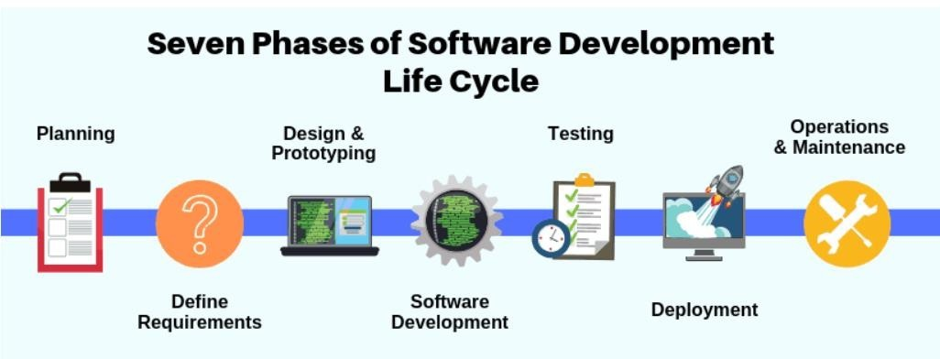

Fig-2.1

Software Development Life Cycle (SDLC) is a process used by the software industry to design,develop and test high-quality software. The SDLC aims to produce high-quality software thatmeets or exceeds customer expectations, and reaches completion within times and costestimates.

* + - SDLC is the acronym of Software Development Life Cycle.
    - It is also called as Software Development Process.
    - SDLC is a framework defining tasks performed at each step in the software development process.
    - ISO/IEC 12207 is an international standard for software life-cycle processes. It aims to be the standard that defines all the tasks required for developing and maintaining software.

SDLC is a process followed for a software project, within a software organization. It consists of a detailed plan describing how to develop, maintain, replace and alter or enhance

specific software. The life cycle defines a methodology for improving the quality of software and the overall development process. Different stages of SDLC are as following:

* + - Planning
    - Define Requirements
    - Design and Prototyping
    - Software Development
    - Testing
    - Deployment
    - Maintenance

## INTRODUCTION TO PROJECT/INTERNSHIP

### INTERNSHIP SUMMARY

A meticulously drafted industrial training can foster the growth of a student both in technical as well as communicational direction. It can help the candidate in developing problem-solving and management skills and can help him/her in understanding the corporate world. During the brief period of my training, I got to know and worked with multiple fields such as javascript typescript expressjs and nestjs the frameworks of nodejs. I got to learn so much from the internship that it is for sure that Industrial training is a vital chapter of a student's life.

### PURPOSE

The objective of my internship was to update my knowledge of the latest technologies and kick-start a career in my field of interest. As I was keenly interested in nodejs, I was assigned a project in this technology. The project that I worked on during my internship has been instrumental in helping me understand the fundamental workings of JavaScript, nodejs, and web development. Through this experience, I have also gained confidence in my development skills as I created the project from scratch and overcame various hurdles through research and guidance from my team seniors and peers.

### OBJECTIVE

The objective of industrial training is to expose students to the industrial demand and also at the same time help them in cultivating necessary skills and practices. The primary objective of this internship is to:

* + - To provide students the opportunity to test their interest in a particular career before permanent commitments are made.
    - To develop skills in the application of theory to practical work situations.
    - To develop skills and techniques directly applicable to their careers.
    - Internships will increase a student's sense of responsibility and good work habits.
    - To expose students to real work environment experience and gain knowledge in writing reports on technical works/projects.

4

### SCOPE

A fitness API for a gym can track gym member health metrics, provide personalized workout plans and dietary recommendations, and integrate with gym equipment to track and analyze workouts. It can also offer social and gamification features to keep gym members motivated and engaged in their fitness journey. In summary, a fitness API for a gym provides a comprehensive and personalized experience to help gym members achieve their fitness goals.

### PROJECT PLANNING AND SCHEDULING

The internship that we completed was for three months during which we were developed in various fields. The overall time period was as follows:

|  |  |
| --- | --- |
| **Time Duration** | **Task Planed** |
| **Week 1 – Week 6** | * **Introduction to JavaScript** * **Introduction to TypeScript** |
| **Week 7 – Week 9** | * **Introduction to nodejs** |
| **Week 10** | **- Introduction to Postgres sql and ExpressJS** |
| **Week 11 – Week 12** | **- Performing Crud operations** |

Table 3.1

## SYSTEM ANALYSIS

System Analysis is the study of a problem domain in order to recommend improvements and specify requirements and priorities to achieve the solution. This phase focused on a more detailed understanding of the problem. Systems analysis is a process of collecting factual data, understand the processes involved, identifying problems and recommending feasible suggestions for improving the system functioning. This involves studying the business processes, gathering operational data, understand the information flow, finding out bottlenecks and evolving solutions for overcoming the weaknesses of the system so as to achieve the organizational goals. System Analysis also includes subdividing of complex process involving the entire system, identification of data store and manual processes.

### Study of Current System

Overall, the current system of fitness apps is focused on providing users with personalized feedback, motivation, and guidance to help them achieve their fitness goals

### 4.2 Problems and Weakness of Current System

Here are some of the most common issues: Inaccurate Data, Limited Scope , User Privacy ,Lack of Integration etc . Also in the frontend there are some of the bugs.

### REQUIREMENTS OF THE NEW SYSTEM.

Overall, the new system should be designed to provide accurate, personalized, and sustainable feedback and guidance to users, while prioritizing user privacy and accessibility. It should also offer a comprehensive approach to health and wellness and integrate well with other health-related platforms.

### Structure Design

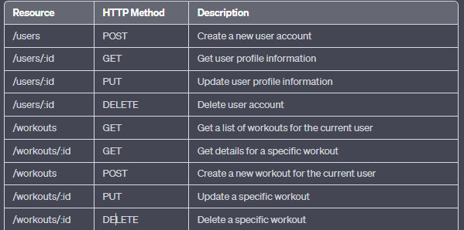

* 1. **System Feasibility**

Fig 4.1

System Feasibility can be considered as preliminary investigation that helps the management to take decision about whether study of system should be feasible for development or not. It identifies the possibility of improving an existing system, developing a new system, andproduce refined estimates for further development of system. It is used to obtain the outline of the problem and decide whether feasible or appropriatesolution exists or not. The output of a feasibility study is a formal system proposal act as decision document whichincludes the complete nature and scope of the proposed system.

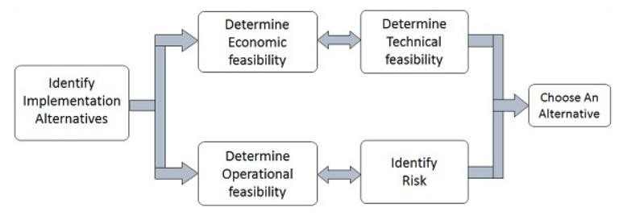

Fig. 4.2

* + 1. **Does the system contribute to the overall objectives of the organization?** The software do resolve the problem and weaknesses of the first system as well as helps in the contribution to the overall objectives of the organization.

### Can the system be implemented using the current technology and within the given cost and schedule constraints?

Yes, the system can be implemented within the applicable cost and must be maintained accordingly. The system is compatible with all of the Web Browsers as well.

### Can the system be integrated with other systems which are already inplace?

Yes, we do have a provision for this as well, at first the compatibility amongst the integrated systems is checked and after confronting the results, one can integrate the system within our software.

### FEATURES OF THE NEW SYSTEM

The features of the new system for a fitness app API could include:

* Accurate Data Collection
* Personalized Coaching and Guidance
* Sustainable Motivation
* Comprehensive Approach
* User Privacy
* Accessibility
* Integration with Other Platforms
* Progress Tracking
* Community Support

### SELECTION OF TECHNOLOGY AND METHODOLOGY

There are various technologies and libraries used in this project which are as following:-

* Backend framework: ExpressJS,nodejs
* Database System: MongoDB
* API Development: Postman

## SYSTEM DESIGN

### SYSTEM DESIGN AND METHODOLOGY

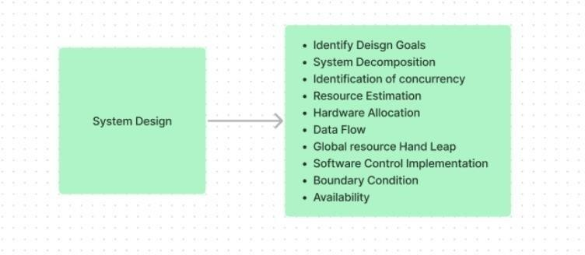System design is the phase that bridges the gap between the problem domain and the existing system in a manageable way. This phase focuses on the solution domain, i.e., “how to implement? In this segment, complete projects and complex tasks were divided into smaller sections. During the internship duration, complex activities were divided into subsequent activities as follows.

Fig 5.1

9

## DATABASE DESIGN

As discussed in the project brief, there are many things to be entered into the database which include the various users table and workouts table.

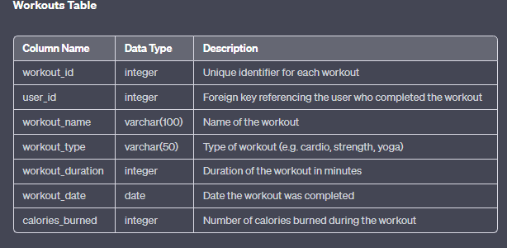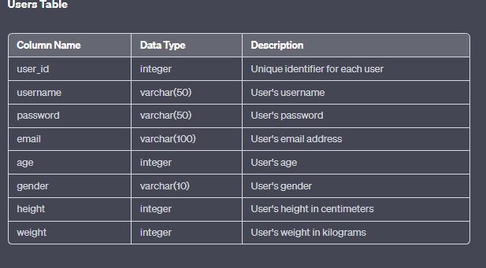

Fig. 5.2

Gujarat Technological University 10 LJIET

## Implementation

### Implementation Platform/Environment

.

Throughout my project and internship, we utilized VScode as our preferred code editor for developing and managing code versions. VScode is an open-source text editor that is available for Windows, Linux, and macOS, offering a lightweight yet feature-rich development environment. Its powerful features have made it increasingly popular in recent times among industrial organizations. The provided demo image showcases the VScode environment and its features.

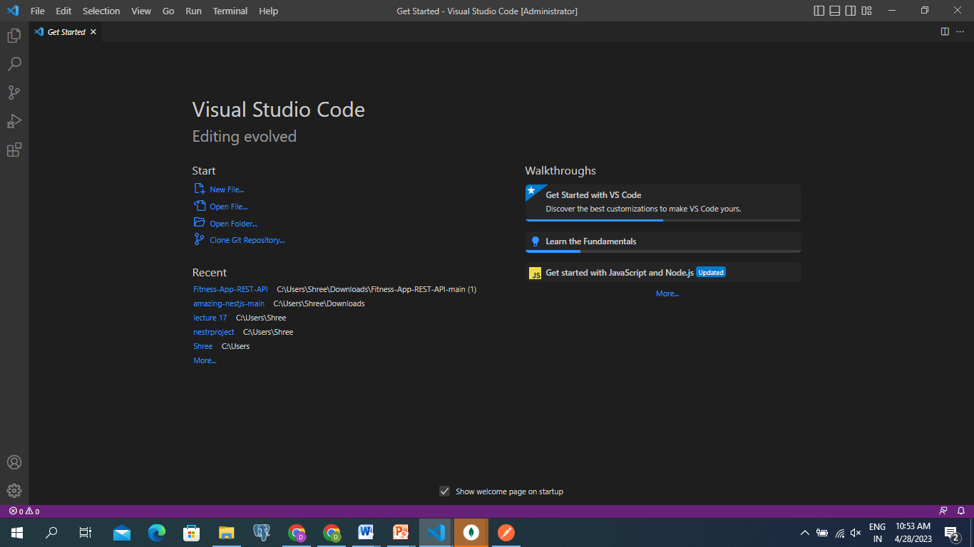

Fig 6.1 VScode

### 

### Program

The screenshots of the code which is shown below is used in the project Fitness App APi .

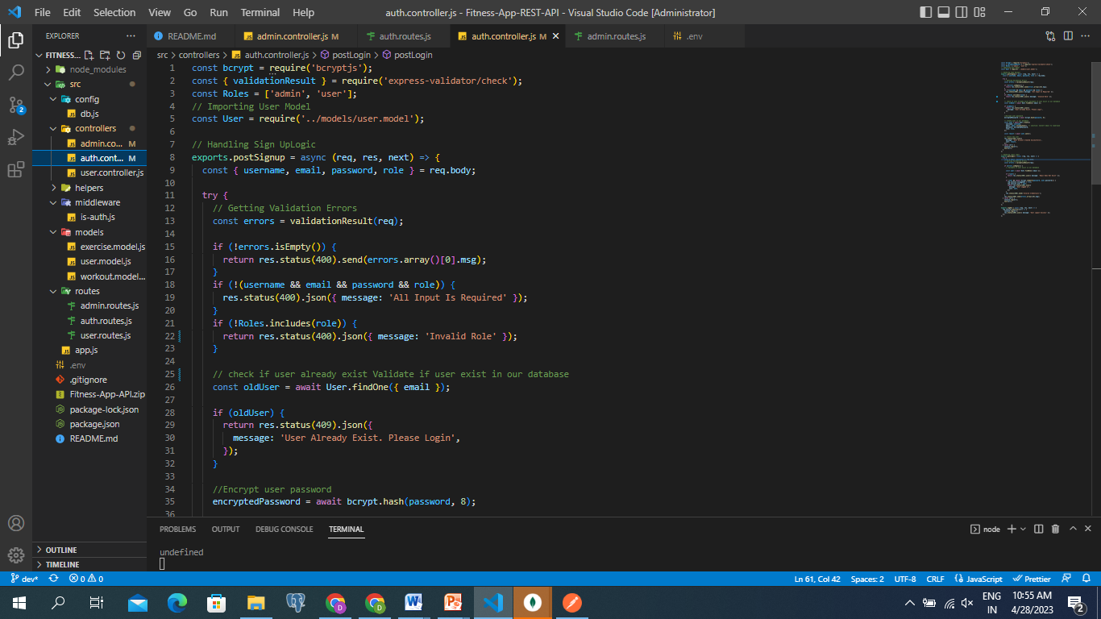

Fig 6.2 Admin Signup

11

Gujarat Technological University LJIET

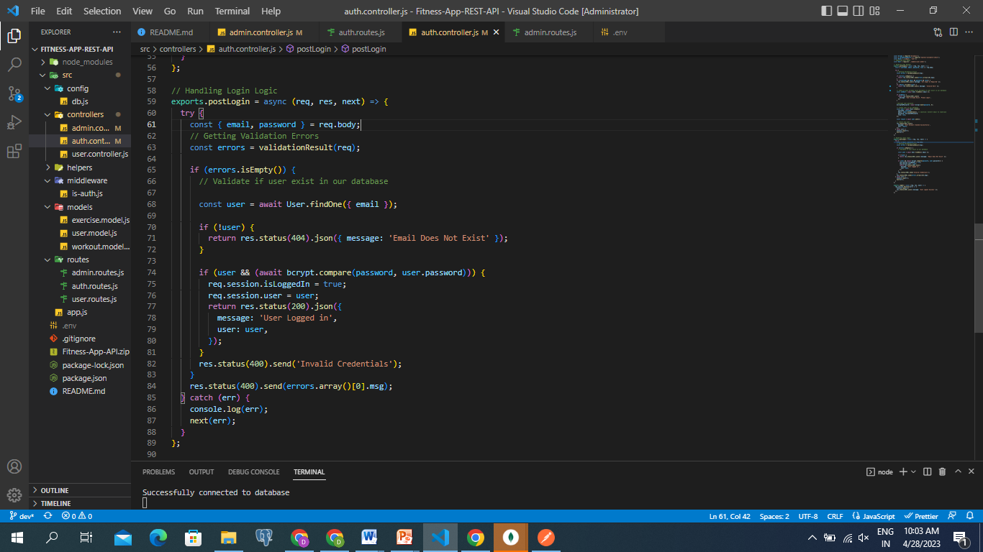

Fig 6.2 Admin login

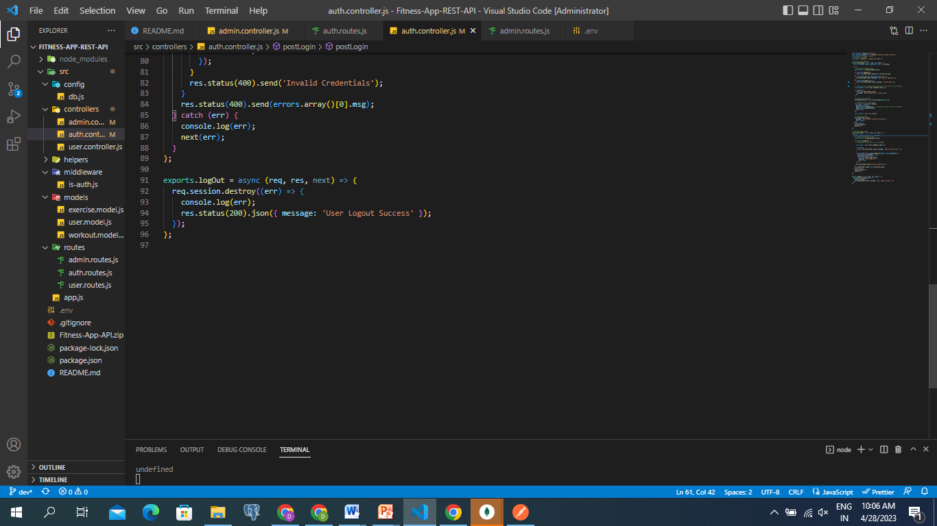

Fig 6.3 Admin Logout

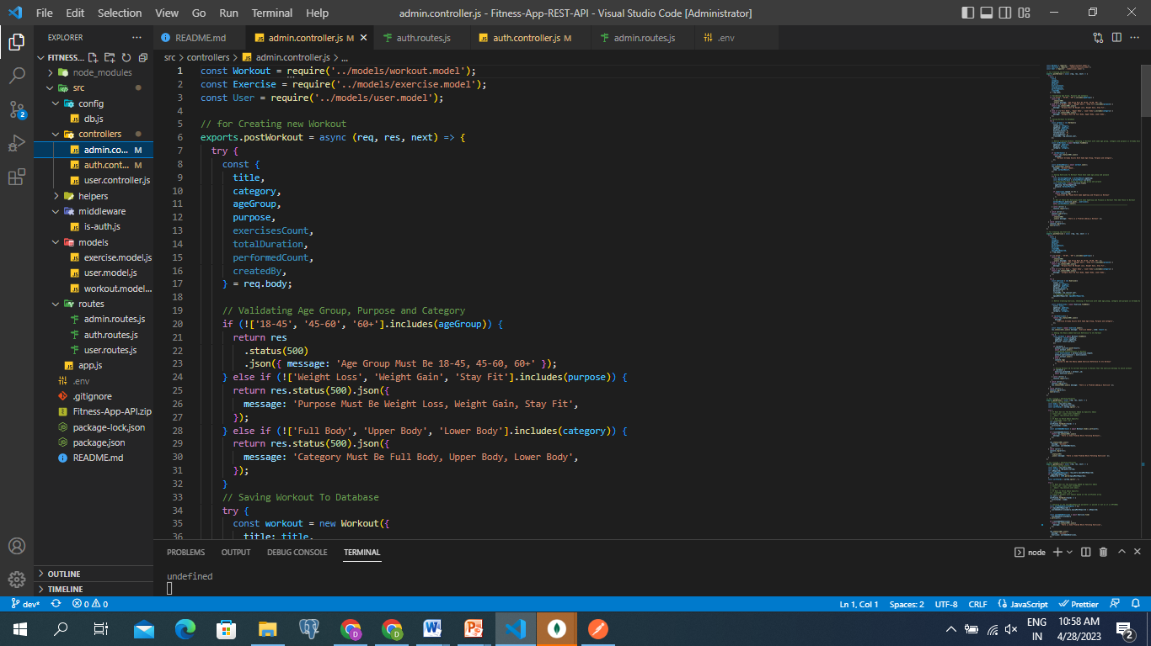

Fig 6.4 Admin Workout

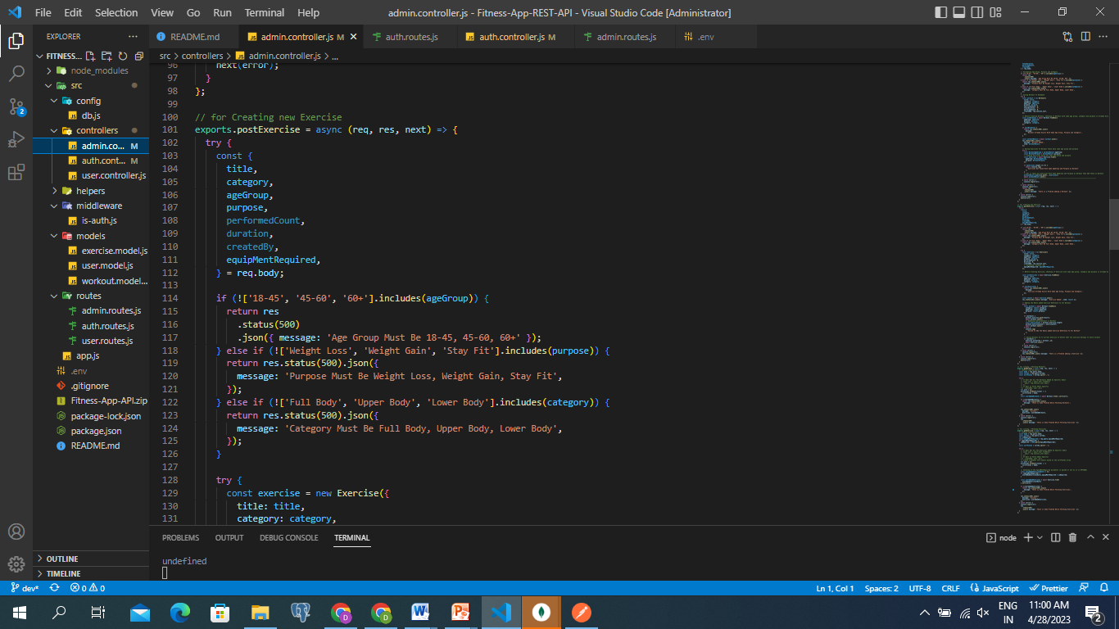

Fig 6.5 Admin Exercise

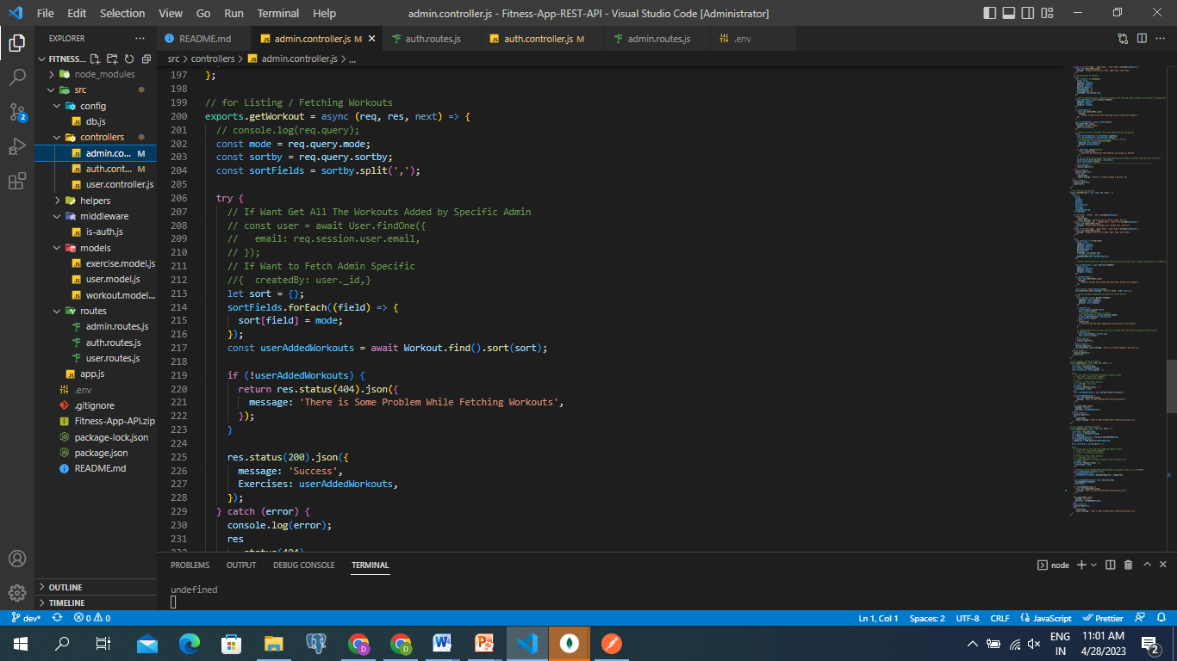

Fig 6.6 Admin Fetching Workouts

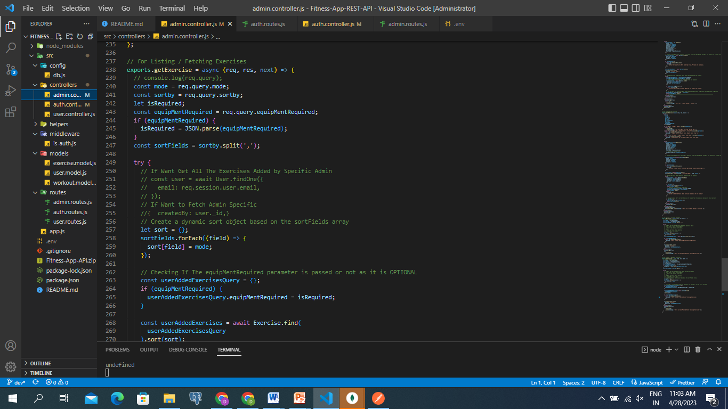

Fig 6.6 Admin Fetching Exercises

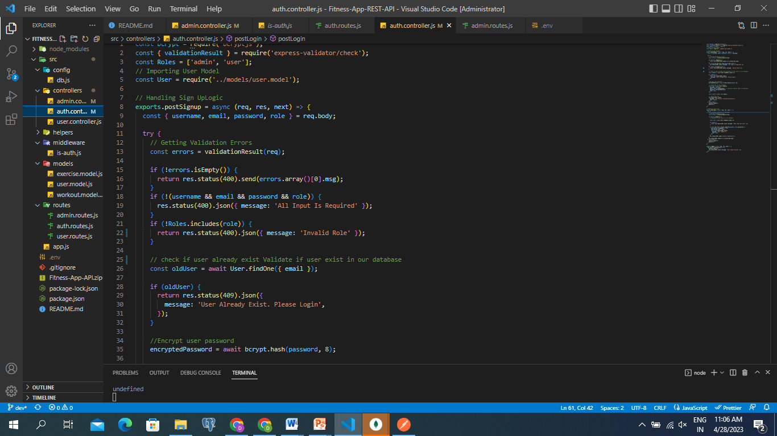

Fig 6.7 Users Register

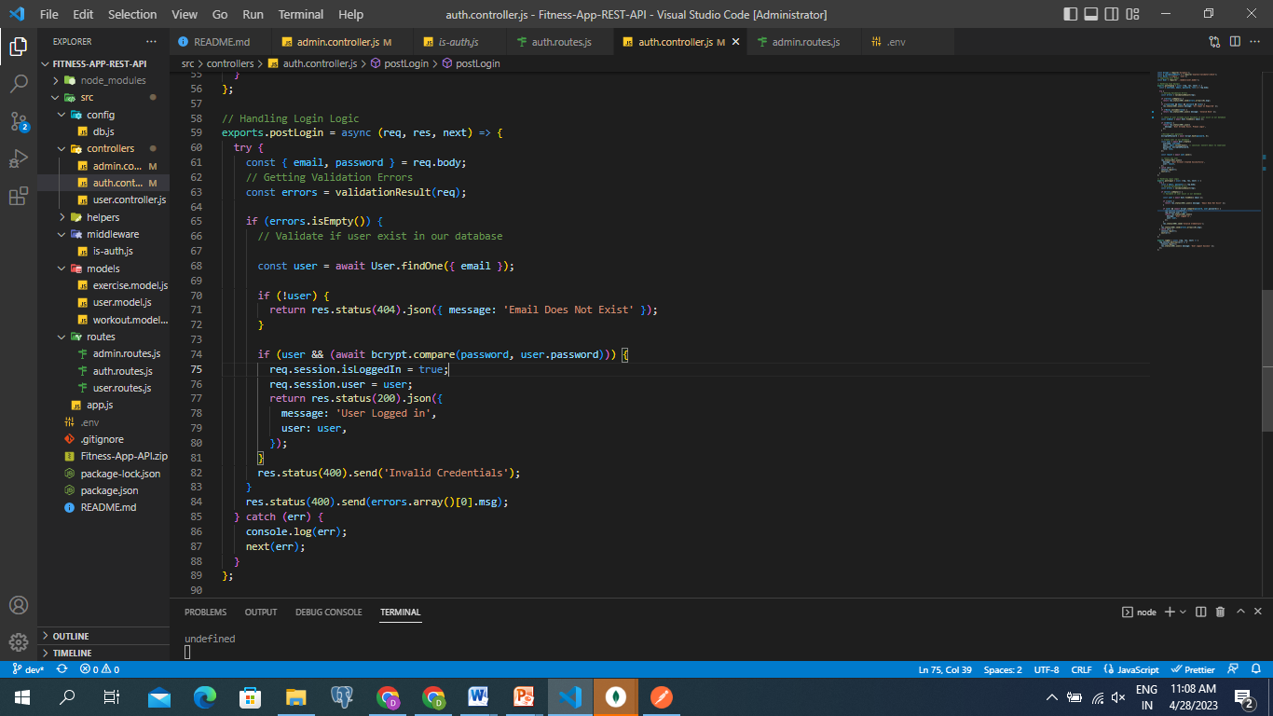

Fig 6.8 Users login

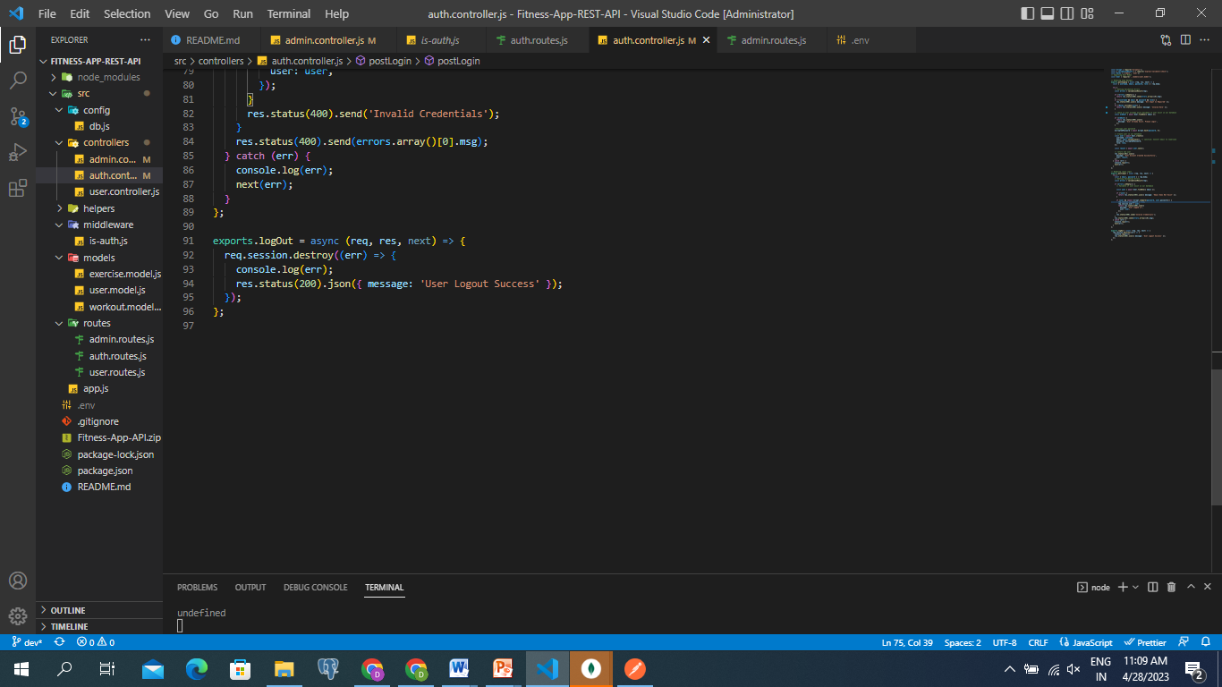

Fig 6.9 Users logout

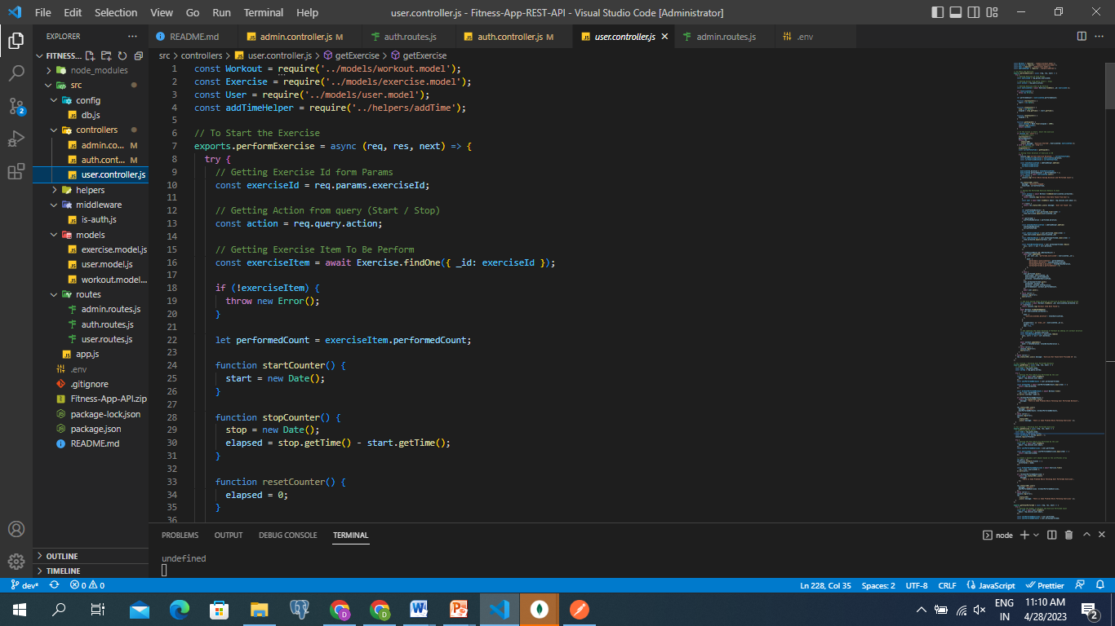

Fig 6.9 Users to perform exercise

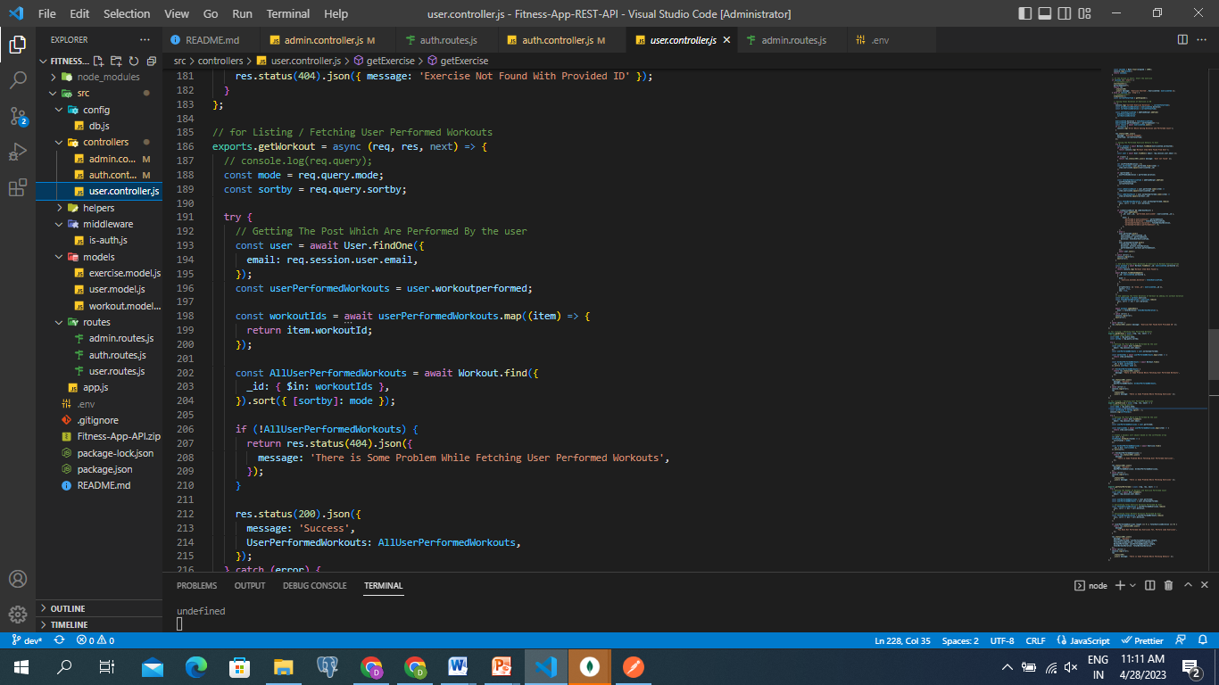

Fig 6.10 Users to perform fetching workouts

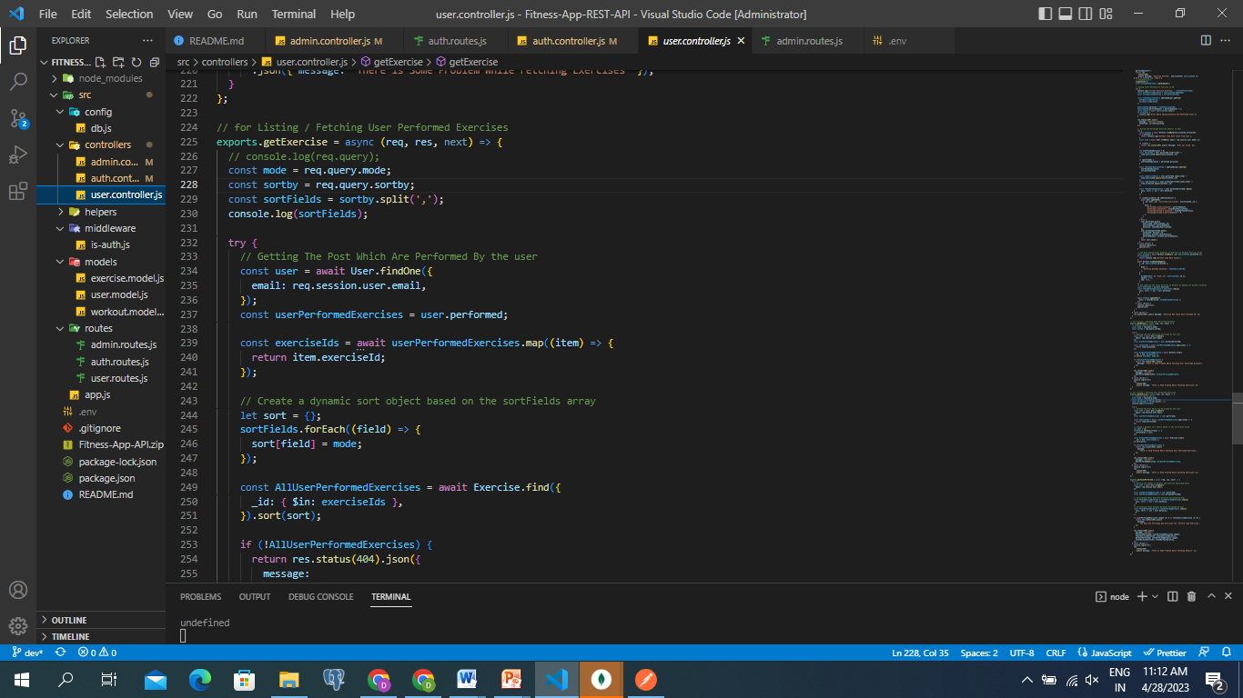

Fig 6.11 Users to perform fetching exercises

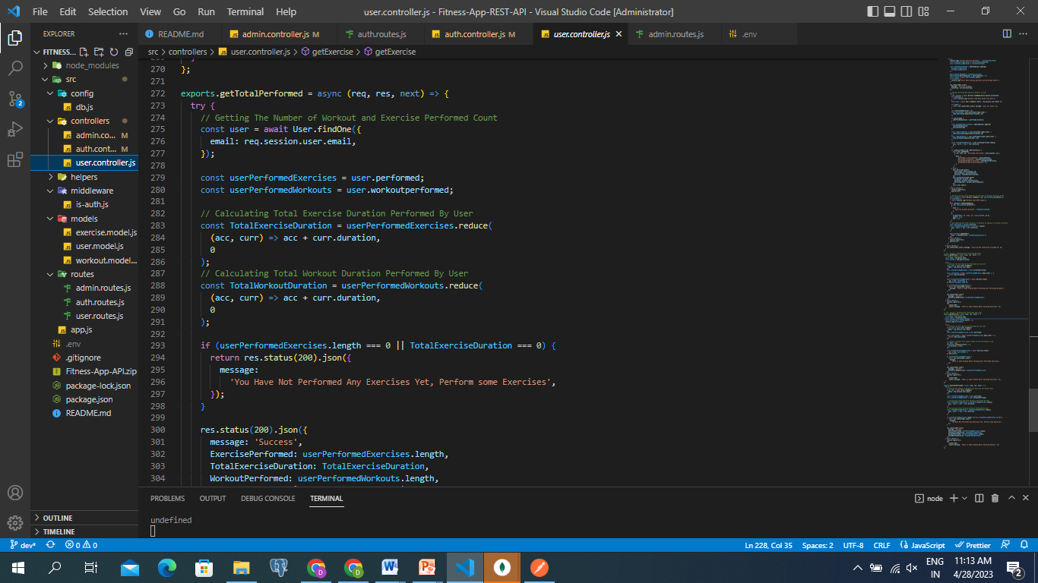

Fig 6.12 Users to perform fetching total performed count

### Results and Outcomes

Following outcomes were obtained after the analytics of the data. It gives the accuracy of the model.

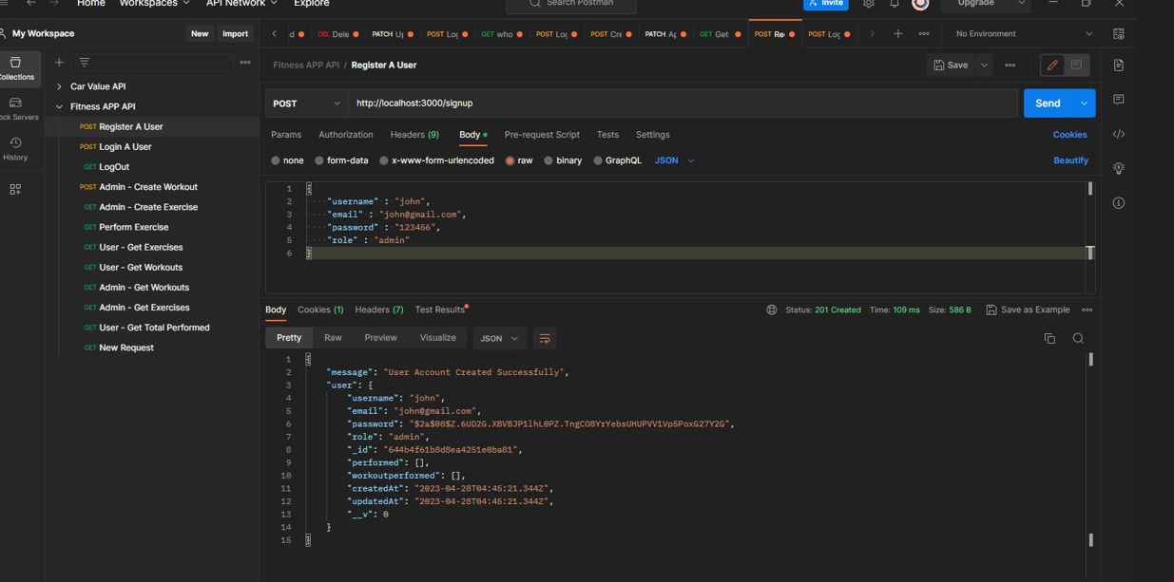

Fig 6.13 Admin Register

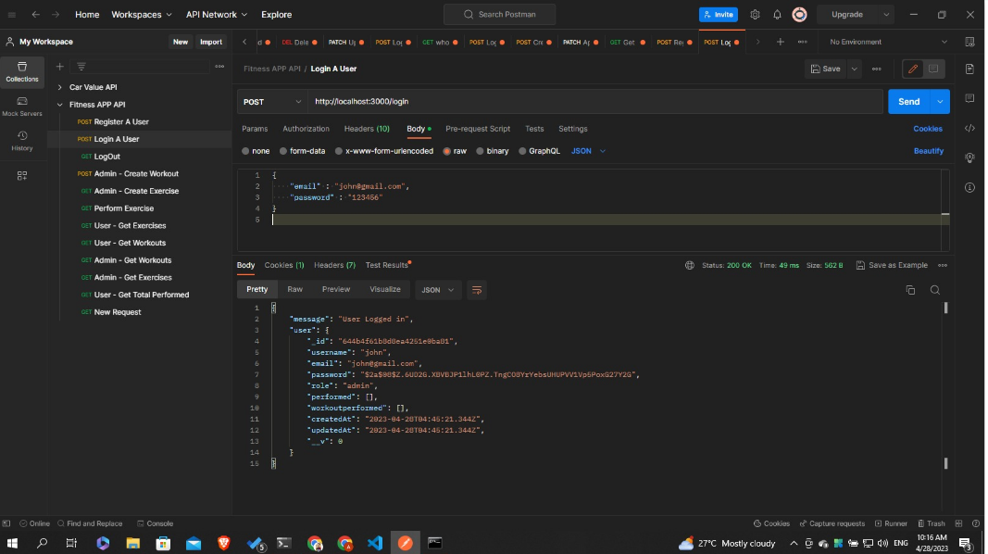

Fig 6.14 Admin Login

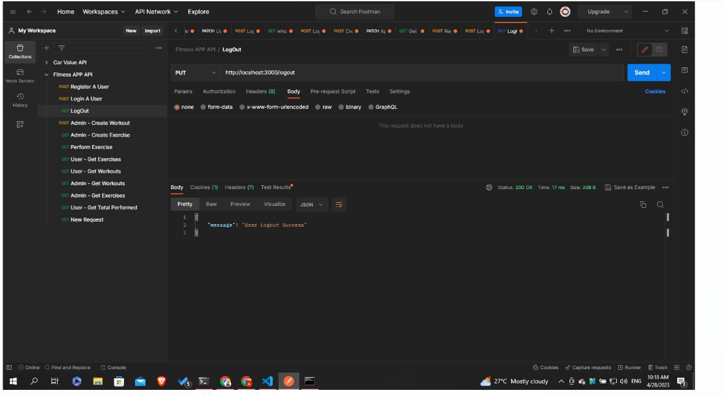

Fig 6.15 Admin logout

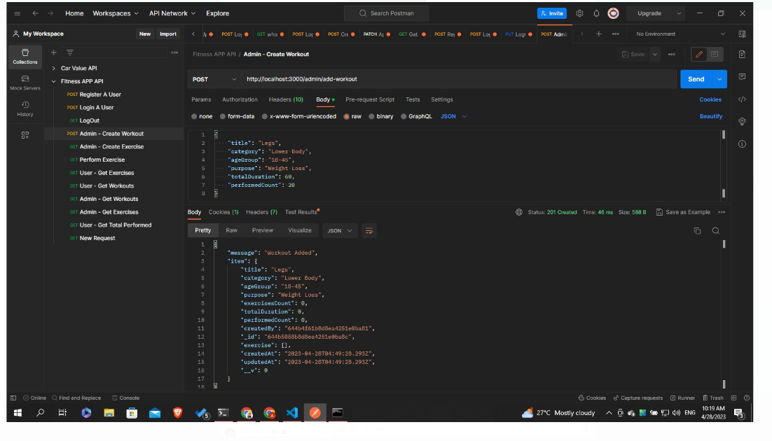

Fig 6.16 Admin add workout

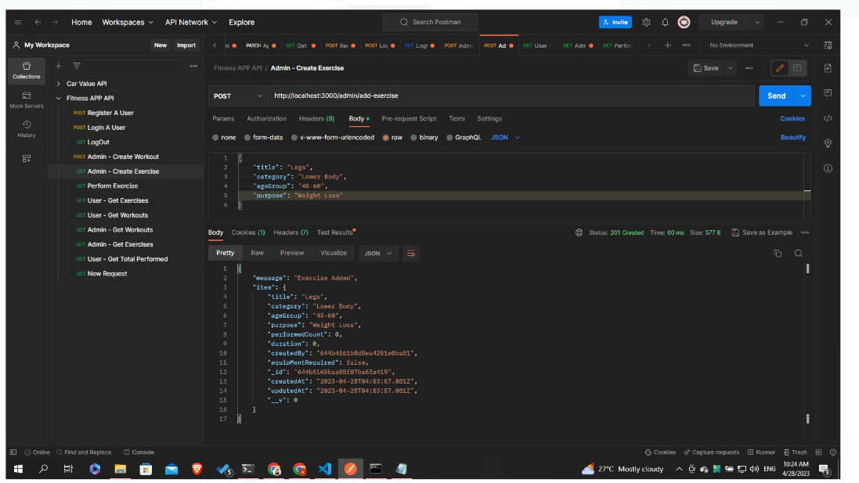

Fig 6.17 Admin add exercises

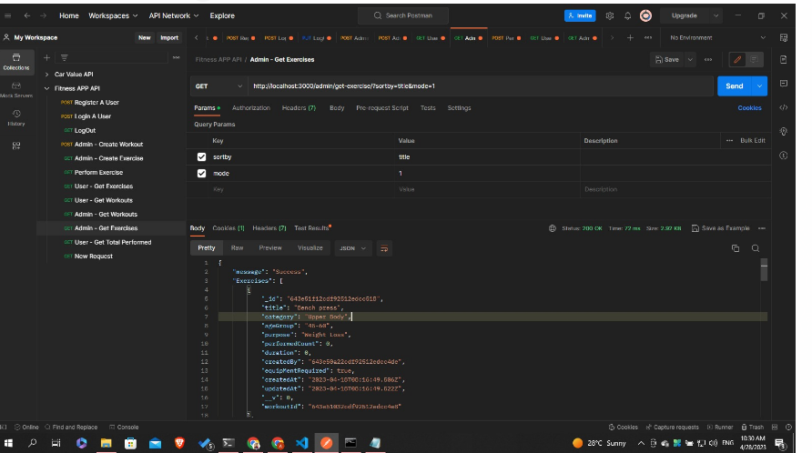

Fig 6.18 Admin fetch total exercises

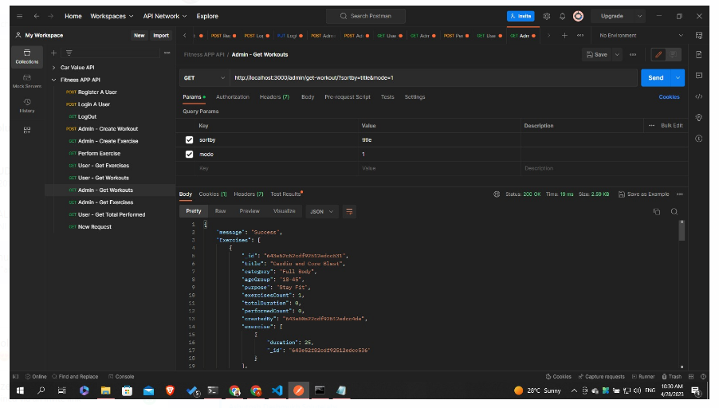

Fig 6.19 Admin fetch total workouts

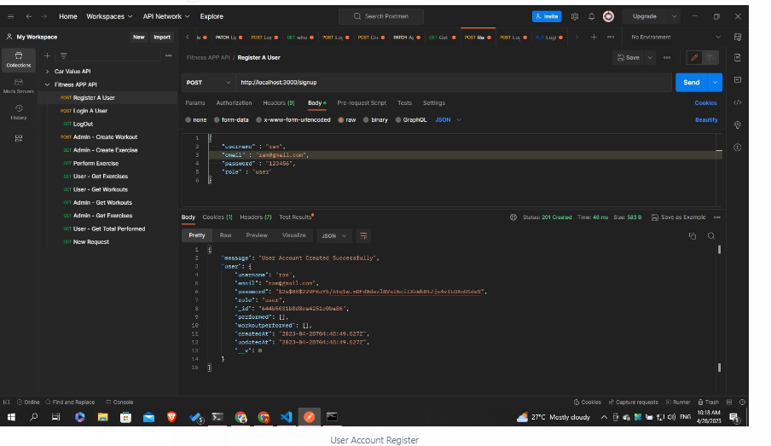

Fig 6.20 User Account Register

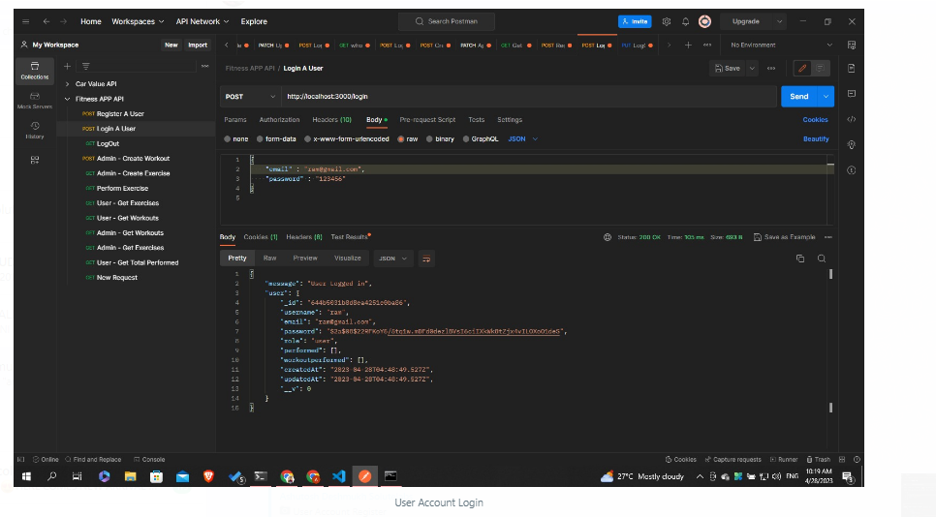

Fig 6.21 User Account login

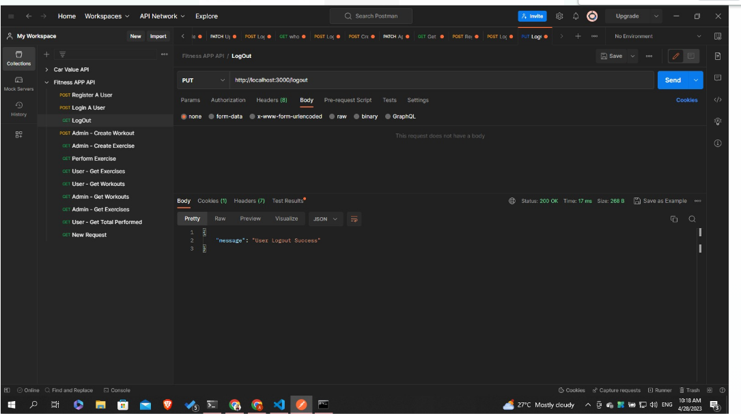

Fig 6.22 User Account logout

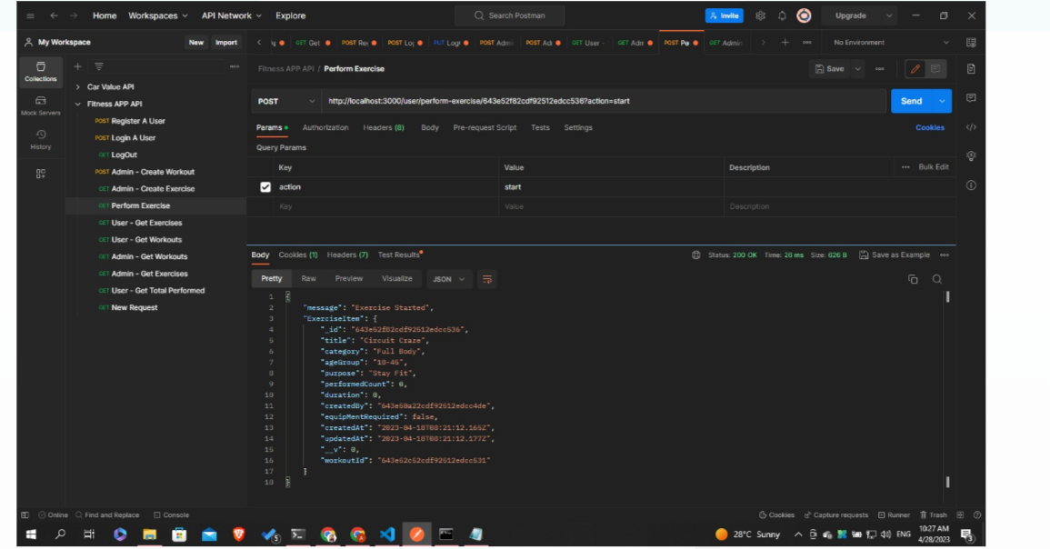

Fig 6.23 User Perform exercise

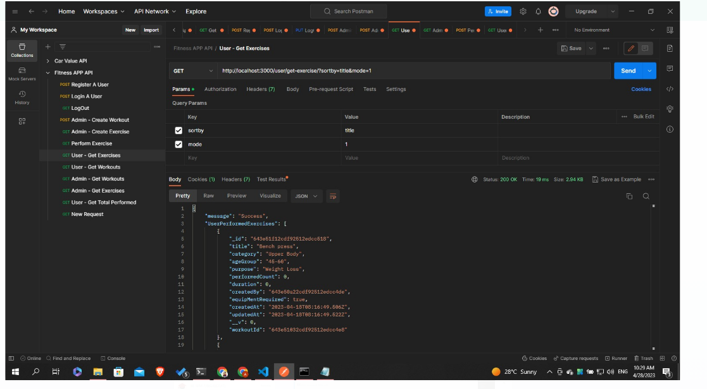

Fig 6.24 User get exercises

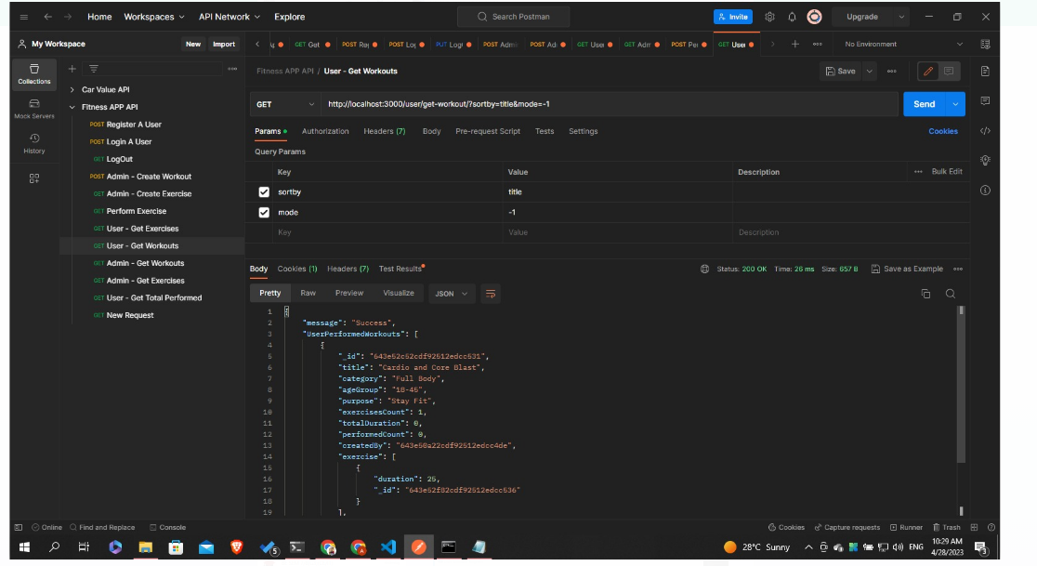

Fig 6.25 User get workouts

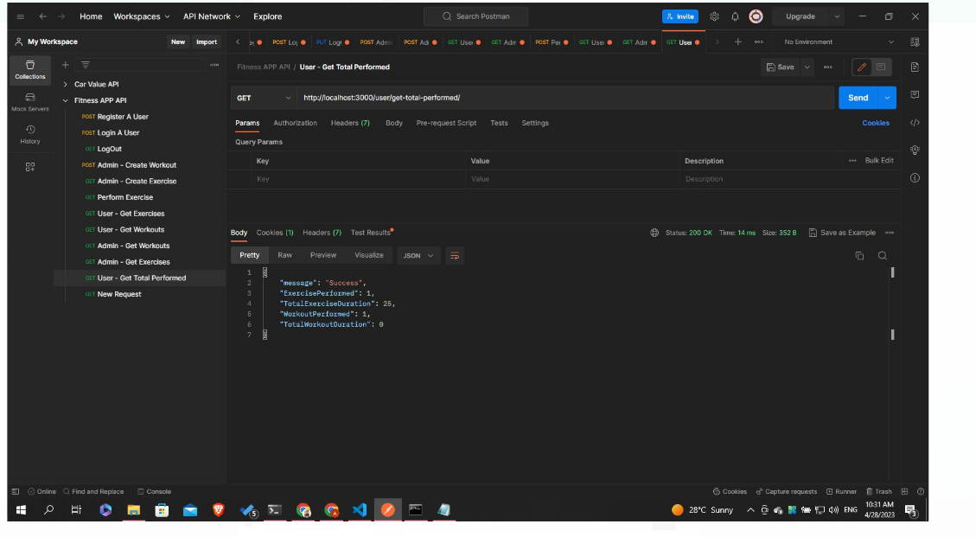

Fig 6.26 User get total performed

## Testing

Testing is the process of executing a program with the aim of finding errors. To make our software perform well it should be error-free. If testing is done successfully it will remove all the errors from the software.

All the test should meet the customer requirements.

Exhaustive testing is not possible. As we need the optimal amount of testing based on therisk assessment of the application.

All the test to be conducted should be planned before implementing it It follows the Pareto rule(80/20 rule) which states that 80% of errors come from 20% of program components.

Start testing with small parts and extend it to large parts.

### Testing Plan/Strategy Software

Testing is a method to check whether the actual software product matches expected requirements and to ensure that the software product is Defect free. It involves the execution of software/system components using manual or automated tools to evaluate one or more properties of interest. The purpose of testing is to identify errors, gaps, or missing requirements in contrast to actual requirements. Here, we have to check the accuracy of the model by which testing can be done on the variety of data.

### Testing Result/Analysis

Testing and analysis are critical parts of the development process for a fitness app API. To perform testing and analysis in brief, you can follow these steps:

1. Plan your tests: Identify the requirements and use cases for the API and create a test plan that covers all necessary scenarios.
2. Prepare test data: Create test data that covers a range of possible inputs and outputs for the API.
3. Execute tests: Run the tests according to the test plan and record the results for each test.
4. Analyze results: Review the test results to identify any issues or bugs in the API.
5. Prioritize issues: Prioritize the issues based on their severity and impact on the user experience and create a plan to address them.
6. Repeat testing: Iterate the testing process as needed to ensure that all issues are resolved and the API meets the required quality standards.

To perform analysis on the testing results, you can look at metrics such as test coverage, test pass rate, response time, error rate, and user satisfaction. By analyzing the results, you can ensure that your fitness app API is reliable, performant, and user-friendly

### 8.0Conclusion

**8.1 Summary of the Back-end Development Design Document :**

The Back-end Development Design Document for the Online Shop Web App project outlines the architecture and implementation details for the server-side components of the application. The following is a summary of the key points:

* **Architecture:** The application follows a three-tier architecture with a presentation layer, business logic layer, and data access layer. The presentation layer is responsible for handling HTTP requests, while the business logic layer performs application-specific operations. The data access layer handles interactions with the database.
* **Programming language and framework:** The back-end of the application is developed using the Node js language and the Express js web framework.
* **APIs:** The application exposes RESTful APIs for various features, including authentication, and order management. These APIs follow industry-standard conventions and are secured using session-based authentication.
* **Database:** The application uses a non- relational database (Mongo db) to store product and order data. The database is designed with normalization and referential.

* **Security:** The application follows industry-standard security practices, including SSL encryption for all network traffic, input validation, and secure password storage using hashing algorithms.

Overall, the Back-end Development Design Document provides a detailed overview of the back-end architecture and implementation details for the Fitness API

**8.2 Next steps for the back-end development process :**

Fitness Api is using Node.js and the Express framework for its back-end development, the next steps in the development process would be as follows:

* **Implementation:** The first step is to implement the design by writing the actual code. The developers will create the necessary components, including models, routes, controllers, and middle wares using Node.js and the Express framework.
* **Testing:** Once the code is written, it needs to be tested thoroughly to ensure it works as intended. The developers will write unit tests, integration tests, and functional tests to verify that the application meets the requirements and specifications outlined in the design document.
* **Debugging:** During testing, developers will identify bugs and errors that need to be fixed. They will debug the code, fix the issues, and retest the application to ensure it is working correctly.
* **Deployment:** Once the application is tested and optimized, it can be deployed to a production environment. This involves setting up the necessary infrastructure, including web servers, load balancers, and databases, and configuring the application to run in a production environment.

Overall, the back-end development process for Fitness API using Node.js and the Express framework involves implementing, testing, debugging, optimizing, deploying, and maintaining the application to ensure it meets the requirements and provides a reliable and scalable back-end component for the project.

## References

* Help for Internet from the following link have been used in perform the task and perform project.
* https://nodejs.org/en/docs
* <https://expressjs.com/>